Food and Nutrition Curriculum and
Teaching Strategies
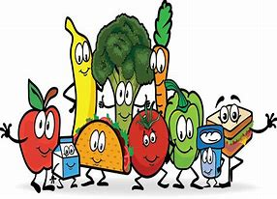
Last year’s response to this workshop was so successful that we are bringing it back with new lessons, strategies and activities. It will bring out the engaged student in you. The curriculum being taught and shared is aligned to the Career and Technical Education (CTE) standards for Food and Nutrition and the CTE Career Ready Standards. As a participant you will have a full hands-on experience. Content will give you new ideas to teach standard FCS material as well as new ready to use classroom materials. A few of the agenda items include:
- Emphasis on: Student Engagement and Inquiry, Standard Based Assessment, and Ready Made Quality Lesson Plans and Rubrics.
- Experimenting how to teach students about evaporation and volume so that they will be able to visualize the concept.
- A demonstration that will emphasize how to complete one of the FCCLA competitions. Participants will judge the presenter’s demonstration using the same rubric to use in your classroom.
- Easy ways to teach math calculations in your foods classes and catering.
- Differentiated instruction strategies for Resource and English Language Learners in the culinary arts lab and classroom.
- Using a variety of equipment in the classroom.

Workshop 1
Date/Location: Tuesday, October 22, 2019, Mission College, Hospitality Management 204A, 3000 Mission College Blvd, Santa Clara, CA 95054
Registration Due: Tuesday, October 1, 2019

Workshop 2
Date/Location: Friday November 15, 2019, Hilton Garden Inn, 1755 South Waterman Ave., San Bernardino, 92408
Registration Due: Friday, November 1, 2019

Workshop 3
Date/Location: Monday, January 27, 2020, San Joaquin County Office of Education, 2901 Arch Airport Rd, Stockton, CA 95206
Registration Due: Tuesday, January 7, 2020

Registration Fee: $130
Workshop Hours: 8:00 a.m. – 3:00 p.m.

