Seafood Croquettes
Cooking Method – Sauté / Bake
Yield – 4 each
Ingredients:
Salt
6 oz Sole filets (boned and skinned, and coarsely chopped)
3 oz Manufacturing Cream, or Ice Water
1 tbls Unsalted Butter
1 tsp Garlic (finely minced)
2 tbls Shallots (brunoise)
2 oz Carrots (brunoise)
2 oz Celery (brunoise)
2 oz Pencil Asparagus (blanched, sliced thinly)
3 oz Medium Shrimp (peeled, deveined, and coarsely chopped )
1 tsp Dill (finely minced)
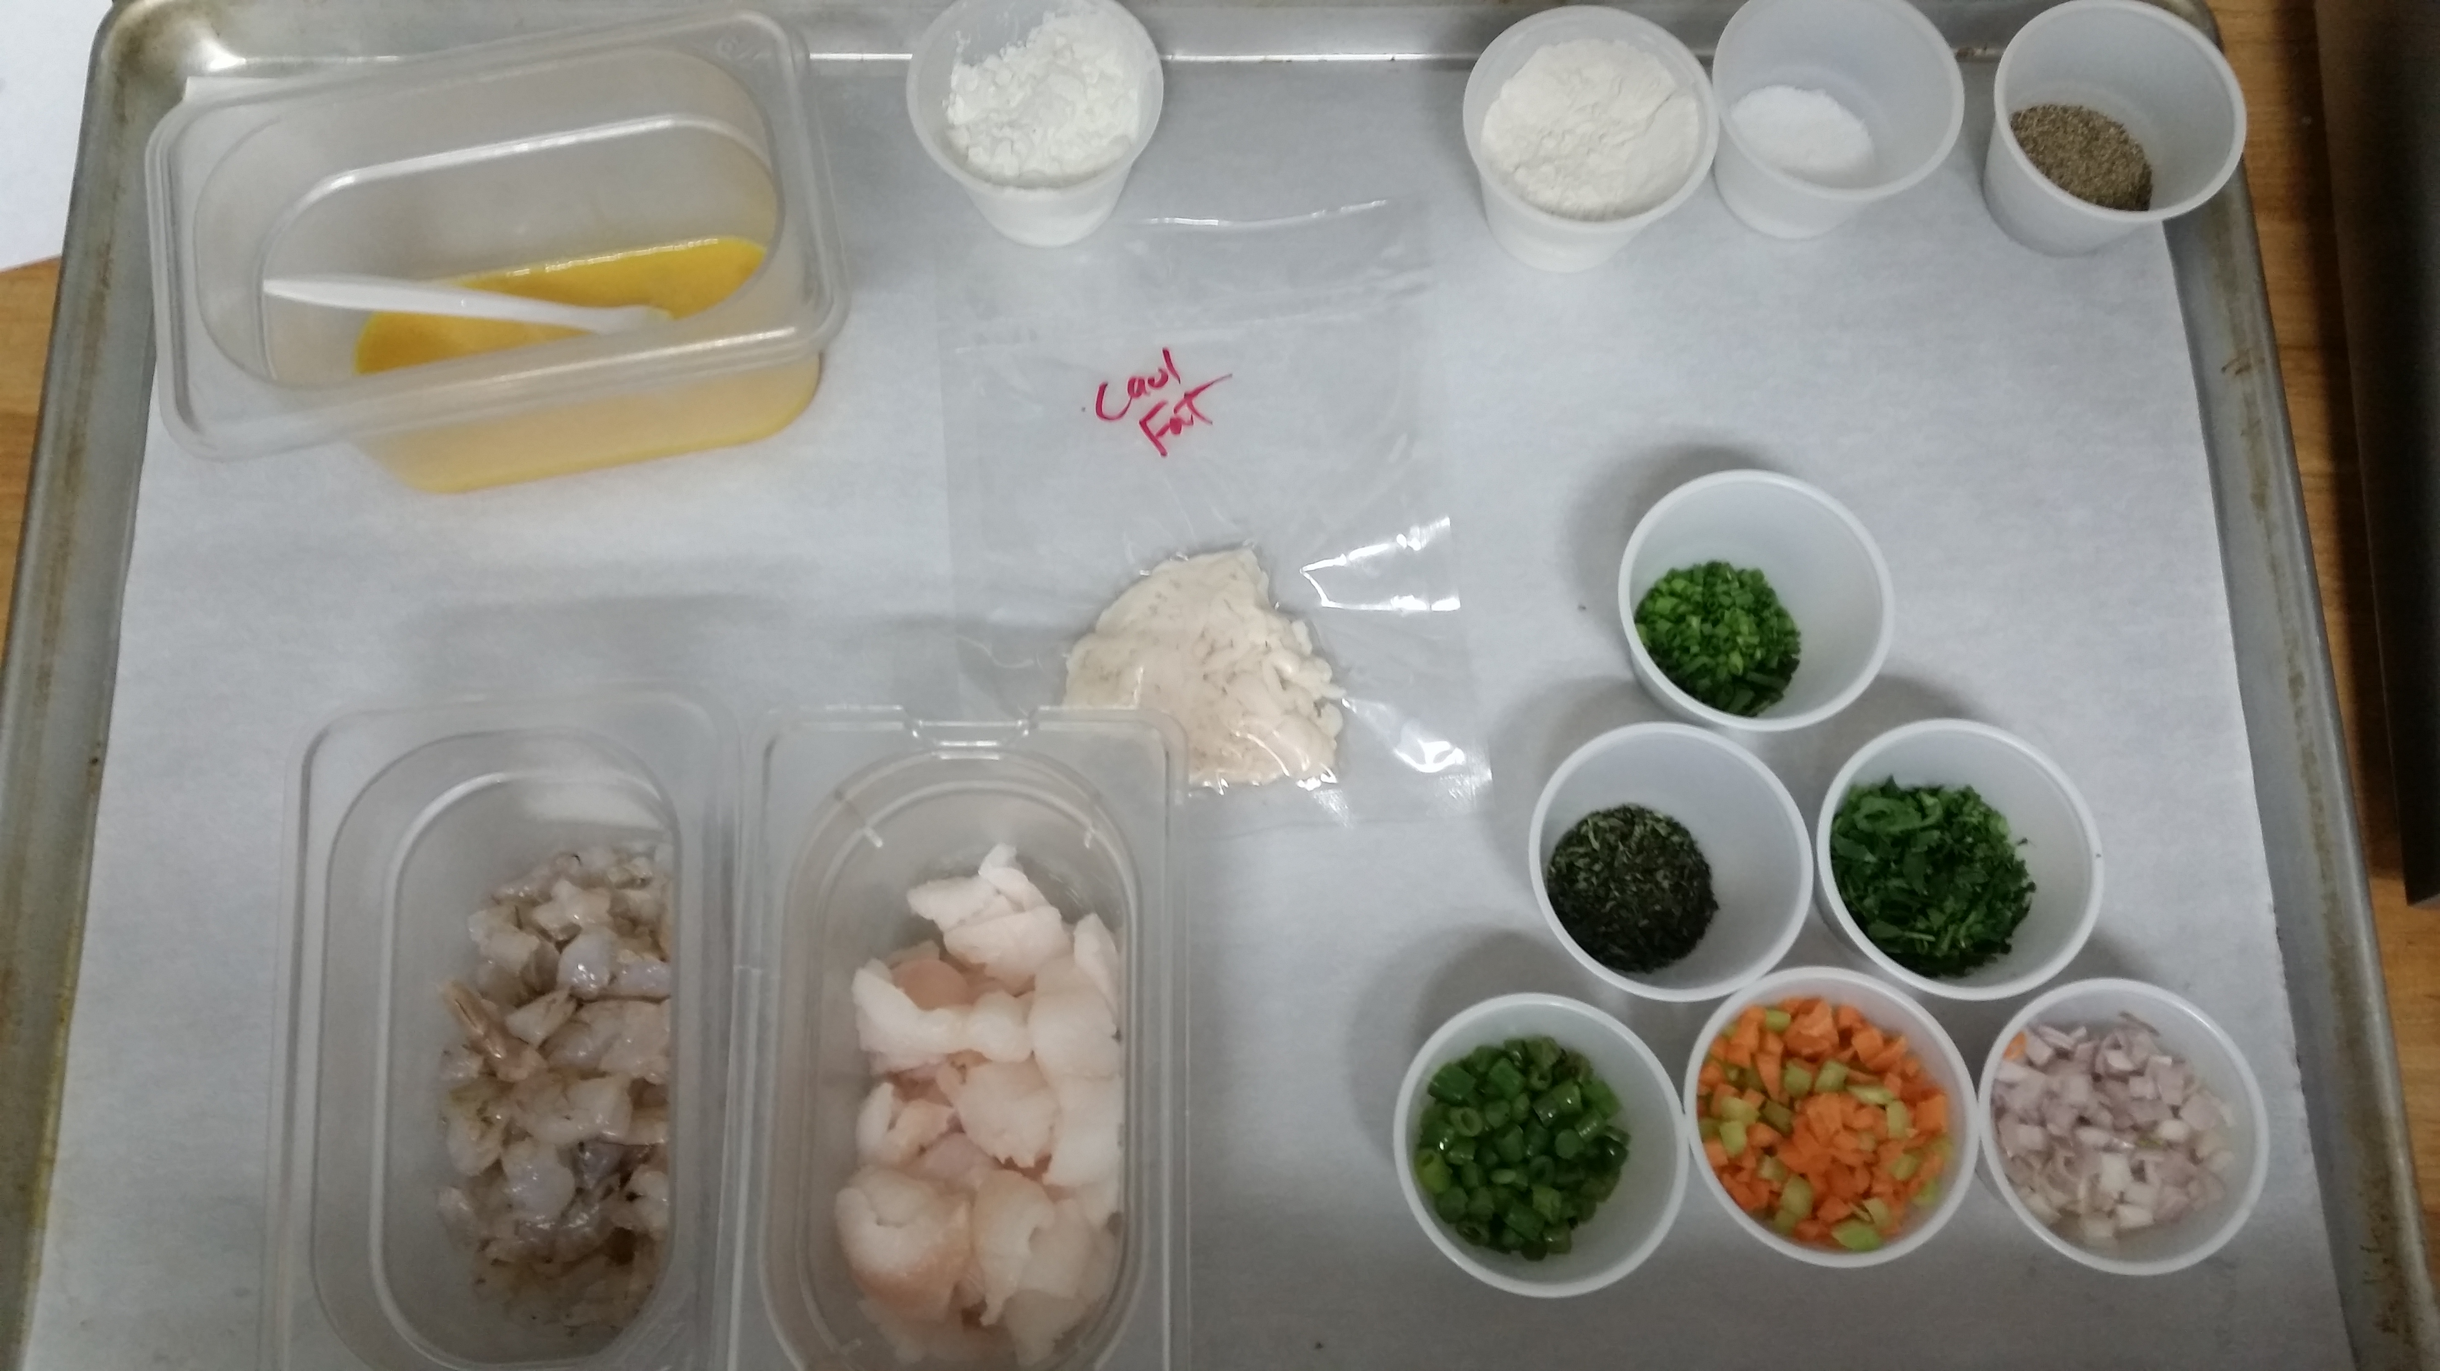
1 tsp Parsley (finely minced)
1 tbls Chives (chopped)
Juice of 1 Lemon, to taste
To Taste Freshly ground white pepper
1/4 lb Caul fat, cut into four 6" x 6" sheets
2 tbls Cornstarch
1 cup Canola/olive oil blend for pan frying
1⁄2 cup Sweet Potato Flour or AP Flour
2 ea Eggs (lightly beaten)

Procedure:

- Place sole and a pinch of salt into a food processor.
- Add cream through feed tube in lid of processor while motor is running until a thick paste forms. Be careful not to over process. A small amount of water can be added if needed.
- Transfer to a medium bowl, cover and set aside in refrigeration.
- Melt butter in a medium sauté pan.
- Add Shallots, Carrots, Celery and Garlic.
- Sweat until aromatic, about 2 minutes.
- Add the blanched Asparagus and sauté for 1 minute more.
- Remove from heat and let cool.
- Once cool, combine with shrimp, dill, parsley, chives.
- Then fold into the sole mixture Season to taste with salt, pepper, and lemon juice.
- Spread sheet of caul fat out on a clean surface with short ends perpendicular to you, removing any large clumps of connective tissue, and cut into 6 inch by 6 inch squares or other desired shape.
- Form filling into a 5" cylinder (or preferred shape) and put in center of caul fat square parallel to you.
- Roll fat around filling, folding in sides halfway through, then sprinkle a little cornstarch on edge of fat farthest from you, moisten with a little water, and press to seal shut.
- Repeat process with remaining fat and filling.
- Combine flour and ¹⁄₄ tsp. pepper in a shallow bowl.
- Working in batches, dip the croquettes into eggs then dredge in flour mixture,
- Heat oil in a heavy bottom pan.
- Brown the croquettes in the pan until golden brown on all sides.
- Drain on paper towels.
- Transfer to a parchment lined sheet pan and finish in a preheated oven set at 350f until croquettes reach an internal temperature of 145 F or desired doneness.

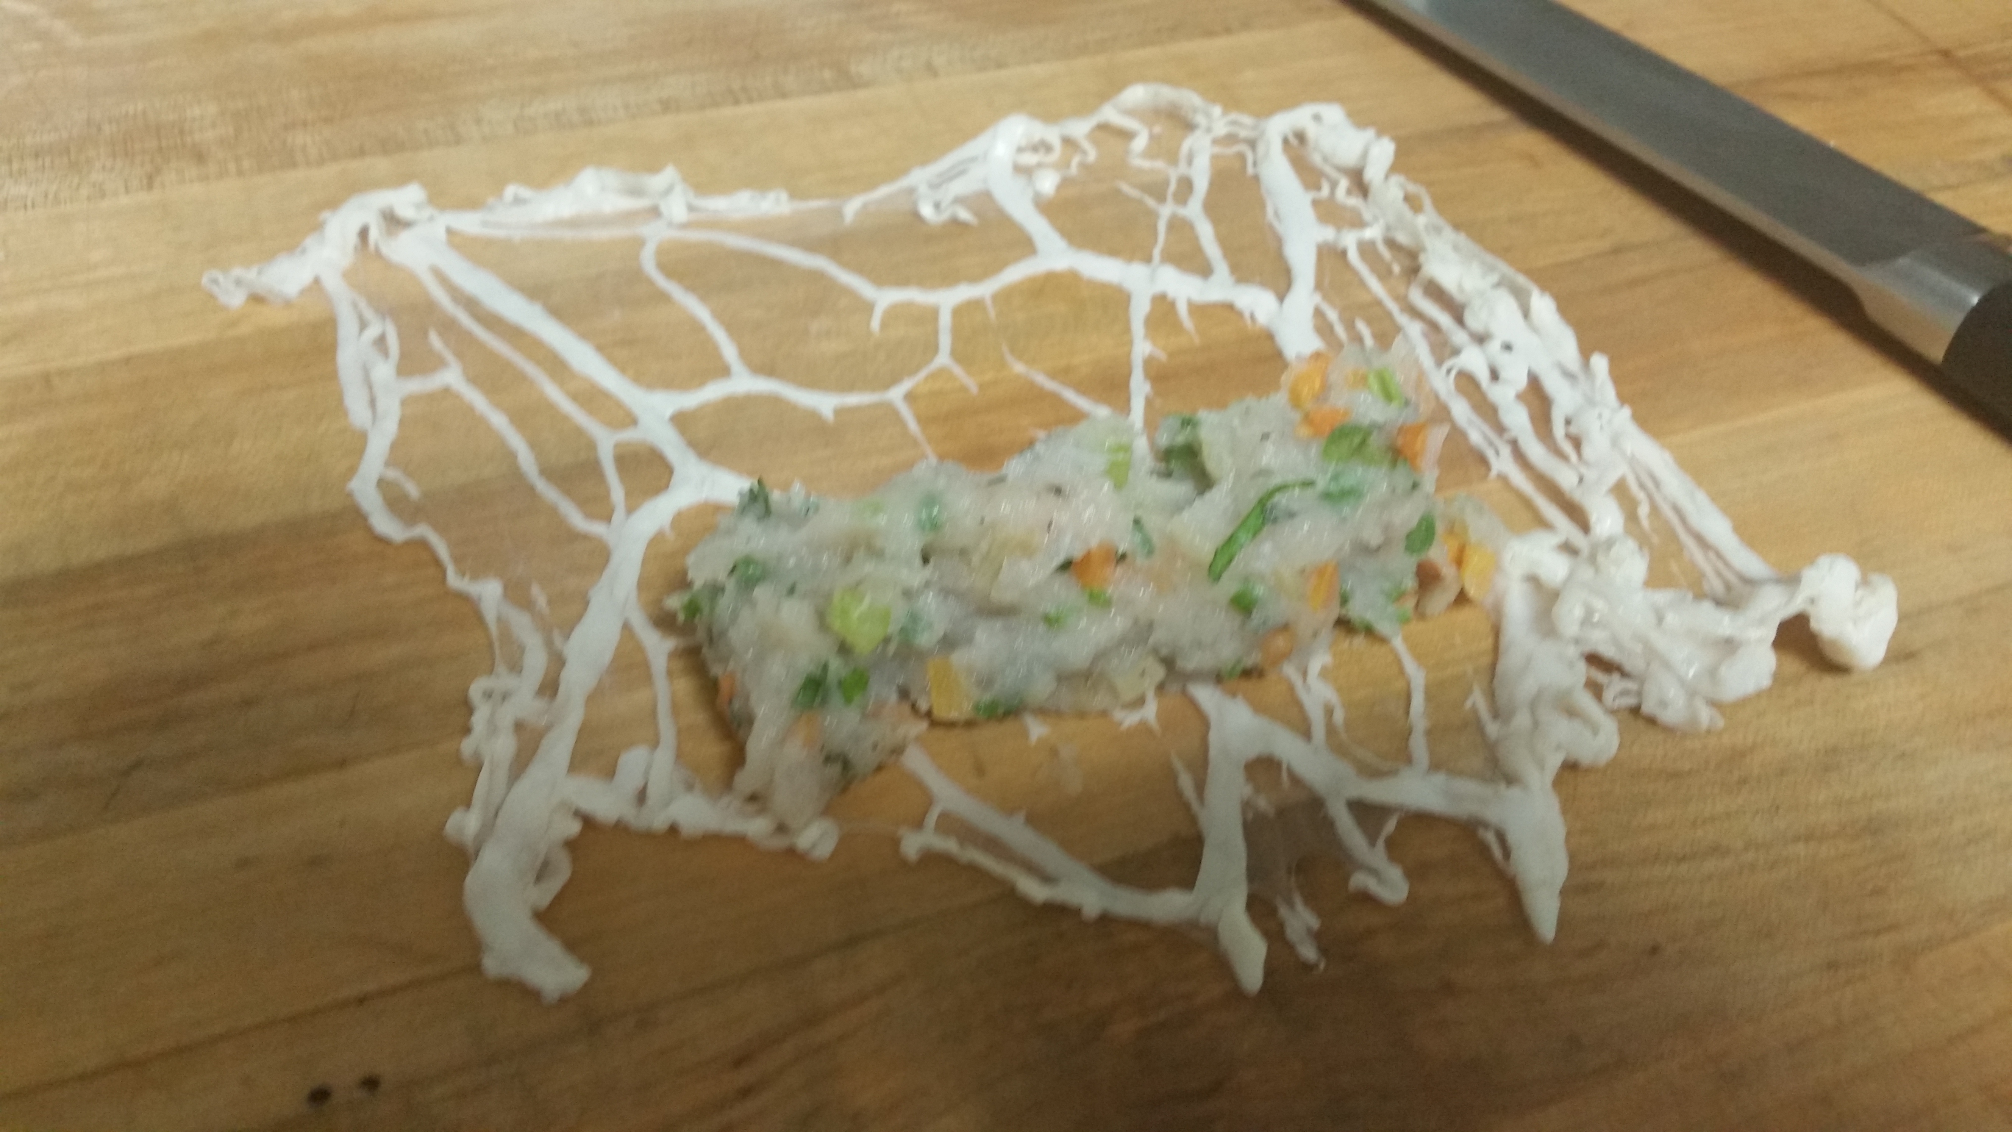

Equipment:
Food Processor
Rubber spatula
Heavy bottom sauté pan
Slotted spoon
1 Half Sheet pan
1 sheet Parchment paper
Pastry bag or spoon to form croquettes
Chef Knife
Cutting board
Small whisk
4 medium stainless steel bowls
Instant Read Thermometer
Plates for service
Utensils

